SPARK SQL PROCESSING

- Show patient name, number of treatments, and age for patients with more than one treatment, sorted by number of treatments descending.
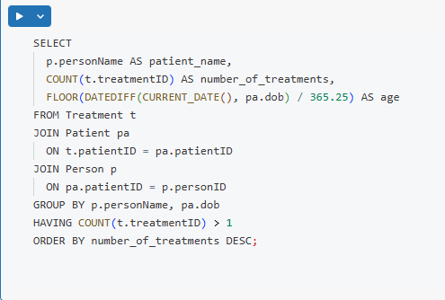
CODE:

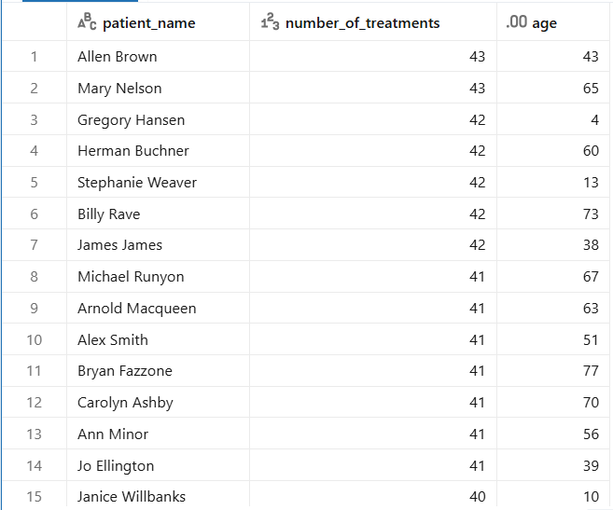
OUTPUT:

- Show for each disease in 2021 the male count, female count, and male-to-female ratio of treatments.
CODE:
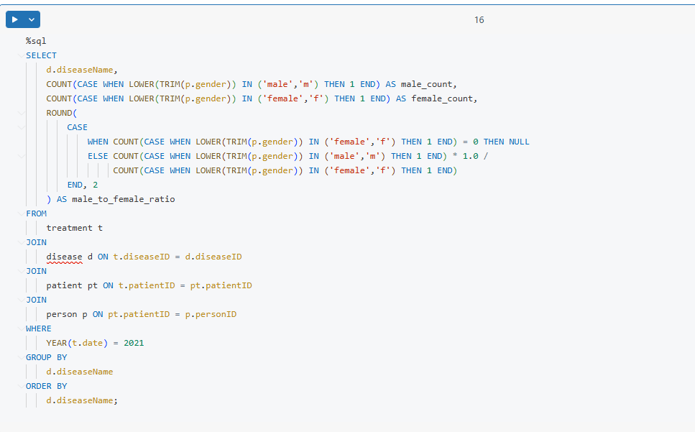
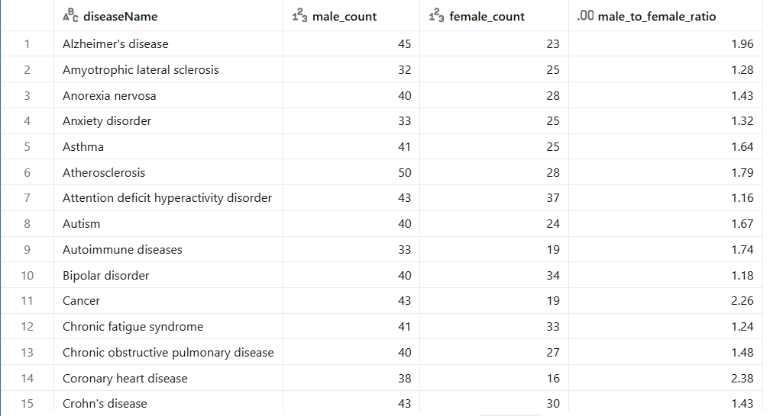
OUTPUT:

- Kelly, from the Fortis Hospital management, has requested a report that shows for each disease, the top 3 cities that had the most number treatment for that disease.
CODE:
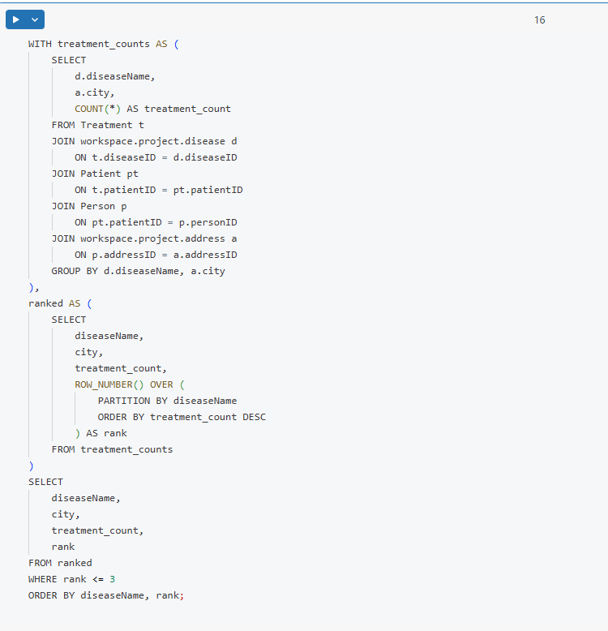

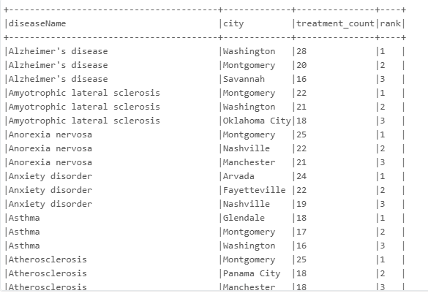
OUTPUT:
- Show each pharmacy name with the number of prescriptions for each disease in 2021 and 2022 as separate columns.
CODE:
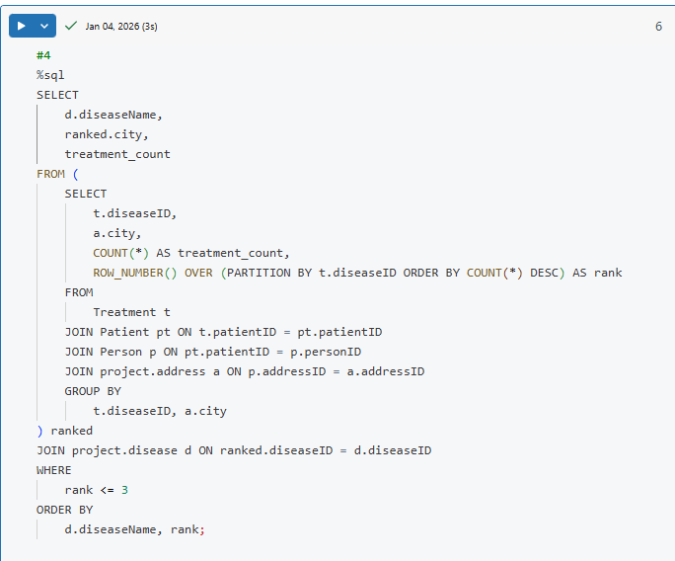
OUTPUT:
